Approval Sheet

Customer：

Item： Ф5LED LAMP

Part No.: WLPD208/3.6G1-07-R-SS

Customer P/N:

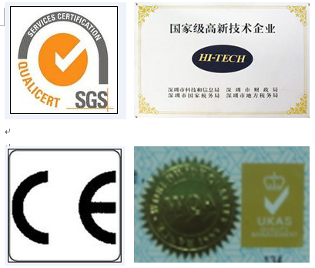
稳亮电子有限公司
WEN LIANG OPTO-ECTRONICS CO.LTD.
Add: 4/F, Building 6,Tian Fu An Industrial Zone,Jiu weiVillage,
xi xiang Town,bao an District shen zhen 518126,china
Tel: 0086-755-29785289
Fax: 0086-755-29785189
E-mail: szwenliang@163.com
Website: http://www.szwenliang.com

PREPARED BY | CHECKED BY | APPROVED BY |  | SIGNATURE | CHECKED BY | APPROVED BY

供方签章： 客户签章：
SUOOLIER： CUSTOMER：

日期： 日期：
DATE： DATE：

备注：承认签章后请回复一份（或复印件）给我公司，其余由贵司留作存盘。如果在签章的承认书（或复印件）回复我司之前，下了有关此零件的订单且又无特殊说明，那么我司就确定贵司已完全承认。
Please return one specification or one copy of it with your chop and signature of approval and retain the others for your record.In the event of an order being placed for this part number before the chop and signed with specification (or copy) is returnde and without special explanation,it will be assumed that full approval have been given.

TYPE NO: WLPD208/3.6G1-07

PACKAGE DIMENSIONS 封装尺寸

Note:
1. All Dimensions are in millimeters
2. Tolerance is ±0.25mm(0.010”)Unless otherwise specified.
3. Protruded resin under flemge is 1.5mm(0.59”)max.
4. This product to static electricity sensitive, Usage the hour please watch for the electricity aegis.

Device Selection Guide
Emitting Color | Lens Type
BLACK | Water Clear
Absolute Maximum Ratings at Ta=25℃
Parameter | RATIG | Unit
VCEO | 30 | V
VECO | 3 | V
Pc 消耗功率 | 70 | mw
TOPR储存温度 | -40℃ to+80℃
Tstg工作温度 | -40℃ to+80℃
Working conditions焊接温度 | 260℃ For 5 Seconds
Electrical Optical Characteristics at Ta=25℃
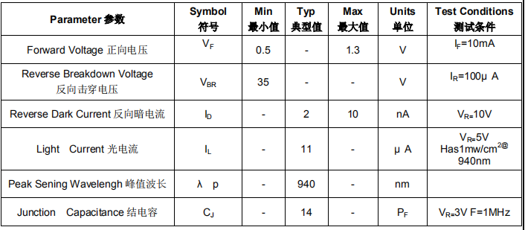

Note.
1. 2θ1/2 is the off axis angle from lamp centerline where the luminous intensity is 1/2 of the peak value.
2. View angle tolerance is ± 10

Typical Electro-Optical Characteristics Curves
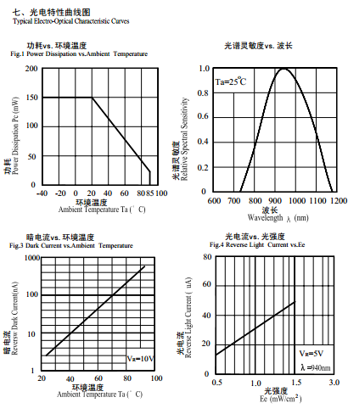

Reliability test items and conditions :
NO | Item | Test Conditions | Test Hours/Cycle | Sample Size | Judgment
1 | Solder Heat | TEMP：260±5℃ | 5 SEC | 76 PCS | OK
2 | Temperature Cycle | H：+85℃ 30min  ∫ 5min  L：-55℃ 30min | 50 CYCLES | 76 PCS | OK
3 | Thermal Shock | H：+100℃ 5min  ∫ 10set  L：-10℃ 5min | 50 CYCLES | 76 PCS | OK
4 | High Temperature Storage | TEMP：100℃ | 1000 HRS | 76 PCS | OK
5 | Low Temperature Storage | TEMP：-55℃ | 1000 HRS | 76 PCS | OK
6 | DC Operating Life | TEMP：25℃ | 1000 HRS | 76 PCS | OK
7 | High Temperature /  High Humidity | 85℃ / 85%RH | 1000 HRS | 76 PCS | OK

Criteria for Judging the Damage：
Measuring Item | Symbol | Measuring Conditions | Judgement criteria for failure
Forward Voltage | VF | IF=20mA | OVER V* 120% OR 80%
Reverse Current | IR | VR=5V | OVER H*2
Luminous Intensity | IV | IF=20mA | L*0.5
Dominant wavelength | λD | nm | OVER±1.5nm(W)

Note:
- V and H means the upper limit of specified characteristics. L and W means initial value
- Measurement shall be taken between 2 hours and after the test pieces have been returned to normal
Ambient conditions after completion of each test.

Packing Specification
◆Anti-electrostatic bag
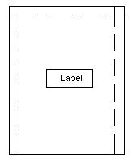
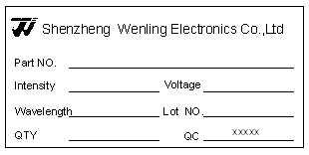

◆Inner Carton
◆Label From Specification
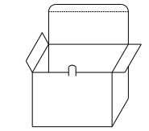
Part NO: Production Number
Intensity: Luminous Intensity
Voltage: Forward Voltage
Wavelength: Dominant Wavelength
Lot NO: Lot Number
QTY: Packing Quantity
QC:BIN Code
◆Outside Carton
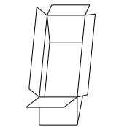

◆Packing Quantity
1.500 PCS/1 Bag,5 Bags/1 Inner Carton
2.10 Inner Cartons/1 Outside Carton

Welding conditions
◆Soldering iron：Soldering iron （up to 30W）tip temperature not exceeding 300 degrees Celsius, the welding time is not more than 3 seconds, welding position at least 3 mm from the gel.
◆Dip soldering: The maximum temperature of dip soldering is 260 degrees Celsius, dip soldering time of less than 5 seconds, dip soldering position at least 3 mm from the gel.
Pin method of forming
◆Bent the lead must be away from the gel of 3 mm. (Picture 1)
◆Lead must be done by fixture or professionals.（Picture 2）
◆Lead must be completed before welding
◆Lead must guarantee pins and spacing consistent with the circuit board
LED assembling method
◆Note the arrangement of various types of component leading-out wires, so as to avoid reversed polarity. The components can't be too close to the heated elements. The working condition should not exceed the prescribed limit.
◆Make sure not mount LED when the lead feet become deformed.（Picture 4）
◆When get down to install in the hole, calculate the size and tolerance of the surface hole and holes pitch of the circuit board, so as the lead not to receive excessive pressure.（Picture 1）
◆We propose the method of mold-guiding position fixing when install the LED
◆Before the welding temperature return to normal, LED must be avoided from any shock or external force.
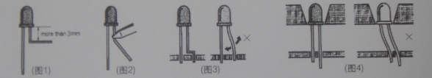

（Picture 1） （Picture 2） （Picture 3） (Picture4）

Wash
Be particularly careful when use chemicals wash the colloid, as some chemicals would damage the colloid surface and arouse color fading, such as TCE and Acetone. Can use ethanol to wipe and soak. Time should never over 1min under the normal temperature.

Working and storage temperatureLED diode Topr-40℃~80℃、Tstg-25℃~100℃

