Approval Sheet

Customer：

Item： TOP VIEW LEDS

Part No.: WLUE2835C-28-Y-A

Customer P/N:

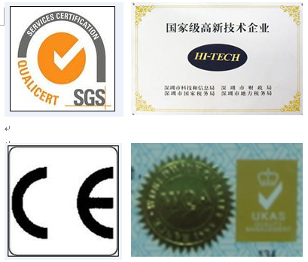
稳亮电子有限公司
WEN LIANG OPTO-ECTRONICS CO.LTD.
Add: Building 6,Xiaweishui Industrial District,
Hongqiaotou Songgang Street, Bao'an,
Shenzhen, Guangdong, China (513000)

Tel: 0086-755-29785289
Fax: 0086-755-29785189
E-mail: szwenliang@163.com
Website: http://www.szwenliang.com.cn

PREPARED BY | CHECKED BY | APPROVED BY |  | SIGNATURE | CHECKED BY | APPROVED BY

供方签章： 客户签章：
SUOOLIER： CUSTOMER：

日期： 日期：
DATE： DATE：

备注：承认签章后请回复一份（或复印件）给我公司，其余由贵司留作存盘。如果在签章的承认书（或复印件）回复我司之前，下了有关此零件的订单且又无特殊说明，那么我司就确定贵司已完全承认。
Please return one specification or one copy of it with your chop and signature of approval and retain the others for your record.In the event of an order being placed for this part number before the chop and signed with specification (or copy) is returnde and without special explanation,it will be assumed that full approval have been given.

TYPE NO: WLUE2835C -28-Y-A

PACKAGE DIMENSIONS

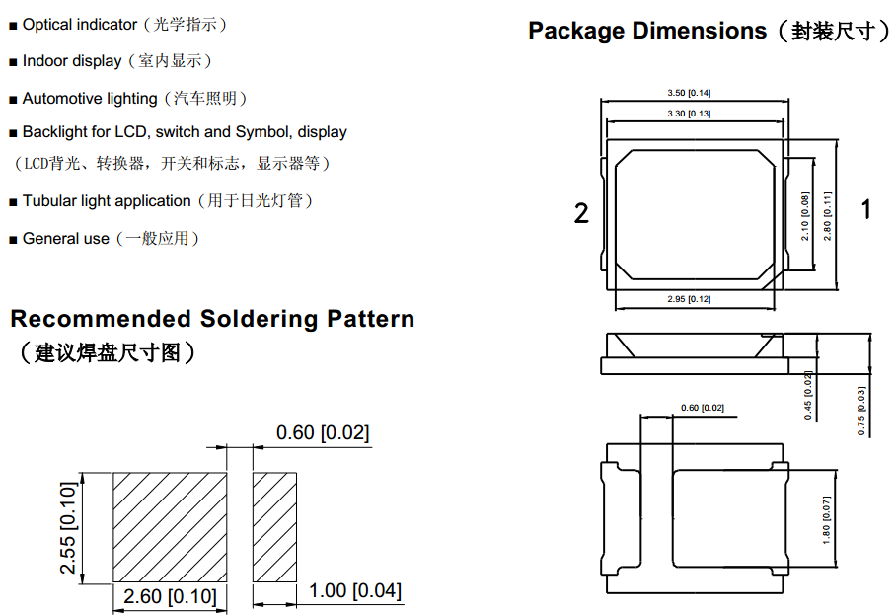

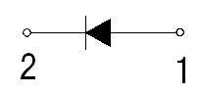

Notes:（ 备注）
1 . All dimension units are millimeters.（ 所有标注尺寸单位为毫米）
2.All dimension tolerance is ±0.15mm unless otherwise noted.（ 除特别标注外， 所有尺寸允许公差±0.15

Device Selection Guide
Emitting Color | Lens Type
Red | Water Clear
Absolute Maximum Ratings at Ta=25℃
Parameter | Symbol | Max | Unit
Power Dissipation | P_{d} | 80 | mW
Peak Forward Current  1/10 Duty Cycle,0.1ms Pulse Width | I_{FP} | 60 | mA
Forward Current | I_{F} | 30 | mA
Reverse Voltage | V_{R} | 5 | V
Operating Temperature Range | Topr | -40℃ to+100℃
Storage Temperature Range | Tstg | -40℃ to+110℃
Lead Soldering Temperature  【3mm From Body】 | Tsol | 260℃ For 5 Seconds
Electrical Optical Characteristics at Ta=25℃
Parameter | Symbol | Min | Typ | Max | Unit | Condition
Forward Voltage | VF | 1.8 | 2.0 | 2.4 | V | IF=20mA
Luminous Intensity | IV | 500 | 800 | 1000 | mcd | IF=20mA
Dominant Wavelength | λd | 620 | 625 | 630 | nm | IF=20mA
Reverse Current | IR | / | / | 5 | μA | VR=5V
Viewing Angle | 2θ1/2 | / | 120 | / | deg | IF=20mA

Note.
1.Tolerance of Luminous Intensity:11%
2.Tolerance of Dominant Wavelength:+1nm
3.Toleance of Forward Voltage:+0.1V

Typical Electro-Optical Characteristics Curves

Soldering condition
Reflow Soldering |  |  | Hand Soldering
 | Lead Solder | Lead – free Solder
Pre-heat | 120~150℃ | 180~200℃ | Temperature | 350℃ Max.
Pre-heat time | 120sec. Max. | 120sec. Max. | Soldering time | 3sec. Max.  (one time only)
Peak temperature | 240℃ Max. | 260℃ Max. | Soldering time | 3sec. Max.  (one time only)
Soldering time | 10sec. Max. | 10sec. Max. | Soldering time | 3sec. Max.  (one time only)
Condition | refer to  Temperature-  Profile 1 | refer to  Temperature-  Profile 2 | Soldering time | 3sec. Max.  (one time only)

Lead Solder
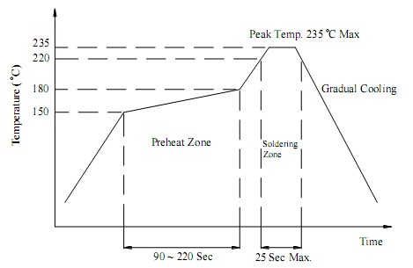

Lead–Free Solder
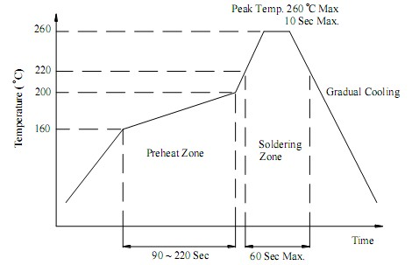

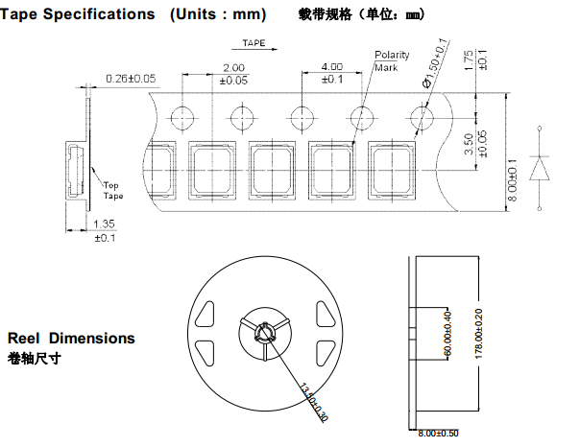

Notes:
- All dimensions are in mm, tolerance is±2.0mm unless otherwise noted.
- Specifications are subject to change without notice.

Packing
1. 4000 piece of SMD 2835 Products on one reel. The reel will be put in the anti-static bag, then sealed.
2. 4000 piece of SMD 2835 products on one bag.
Caution
1.Before open the package, should kept at 30℃, 90% RHenvironmentor less, The LED should be used within a year.
2.After open the package, the LED should be kept at 30℃, 60 % RH environment or less. The LED should be soldered within 24 hours (1days ) after opening the package. If unused LEDs remain, they should be stored in moisture proof packages, such as sealed containers with packages of moisture absorbent material (silica gel).
3.The SMD LED is an ESD sensitive device. All the equipment and machine must be properly grounded.
4.Applying proper resistor for the circuit design is recommended. Otherwise slight voltage shift may cause big current change and the LED may be burn out.
5.LED module of 2 pcs (including more than 2 pcs), we suggest that different reels do not assemble together at the same module.
6.LED Pre-Bake Notice:After the package opening over 24 hrs in 30℃, 60% RH or less. LED should be baked at70±5℃/ 24 hrs before using.
7.The design ofBack Light Module (BLM) is proposed: LEDs and BLM’s frameshould keep 0.4 mm of distances, or insulate between them, in order to avoid shorting out.

