Approval Sheet

Customer：

Item： TOP VIEW LEDS

Part No.: WLUE2835D-1105-Y

Customer P/N:

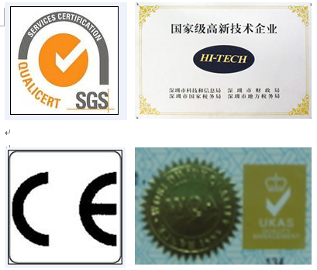
稳亮电子股份有限公司
WEN LIANG OPTO-ECTRONICS CO.LTD.
Add: Building 6,Xiaweishui Industrial District,
Hongqiaotou Songgang Street, Bao'an,
Shenzhen, Guangdong, China (513000)
Tel: 0086-755-29785289
Fax: 0086-755-29785189
E-mail: szwenliang@163.com
Website: http://www.szwenliang.com

PREPARED BY | CHECKED BY | APPROVED BY |  | SIGNATURE | CHECKED BY | APPROVED BY

供方签章： 客户签章：
SUOOLIER： CUSTOMER：

日期： 日期：
DATE： DATE：
备注：承认签章后请回复一份（或复印件）给我公司，其余由贵司留作存盘。如果在签章的承认书（或复印件）回复我司之前，下了有关此零件的订单且又无特殊说明，那么我司就确定贵司已完全承认。
Please return one specification or one copy of it with your chop and signature of approval and retain the others for your record.In the event of an order being placed for this part number before the chop and signed with specification (or copy) is returnde and without special explanation,it will be assumed that full approval have been given.

TYPE NO: WLUE2835D-1105-Y

PACKAGE DIMENSIONS

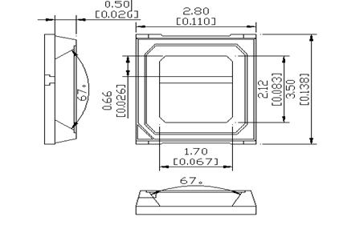

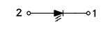

Note:
1. All Dimensions are in millimeters
2. Tolerance is ±0.1mm Unless otherwise specified.

Device Selection Guide
Emitting Color | Lens Type
Red | Water Clear
Absolute Maximum Ratings at Ta=25℃
Parameter | Symbol | Max | Unit
Power Dissipation | P_{d} | 206 | mW
Peak Forward Current  1/10 Duty Cycle,0.1ms Pulse Width | I_{FP} | 200 | mA
Forward Current | I_{F} | 30 | mA
Reverse Voltage | V_{R} | 5 | V
Operating Temperature Range | Topr | -40℃ to+100℃
Storage Temperature Range | Tstg | -40℃ to+100℃
- ** LED allowable pressure value during SMT process.
- Electrical Optical Characteristics at Ta=25℃
Parameter | Symbol | Min | Typ | Max | Unit | Condition
Forward Voltage | VF | 2.0 | 2.2 | 2.4 | V | IF=150mA
Luminous Intensity | IV | 8 | 10 | -- | Lm | IF=150mA
Dominant Wavelength | λd | 620 | 625 | 630 | nm | IF=150mA
Color Rendering Index | -- | -- | -- | -- | -- | IF=150mA
Reverse Current | IR | / | / | 5 | μA | VR=5V
Viewing Angle | 2θ1/2 | / | 120 | / | deg | IF=150mA

Note.
1. The Forward Voltage tolerance is ± 0.03V.
2. Correlated color Temperature is derived from the CIE 1931 Chromaticity diagram.
3. The luminous intensity tolerance is ± 10%

Typical Electro-Optical Characteristics Curves

Surface Mounting Condition
In the automatic mounting of the SMD LED to the PCB, any bending, expanding, and pulling forces against the SMD LED should be minimized to prevent the electrical failures or mechanical damaged.

Reflow Soldering and Temperature Profile
The SMD LED is designed for the reflow soldering process. Too high temperature or too large temperature gradient may cause the electrical and optical failures

Lead Solder
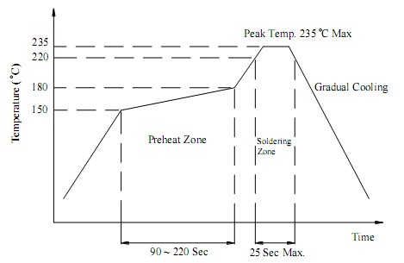

Lead–Free Solder
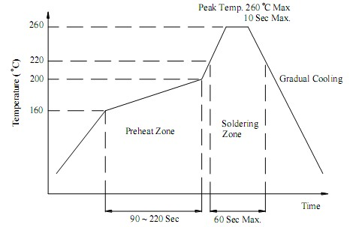
CarrierTape
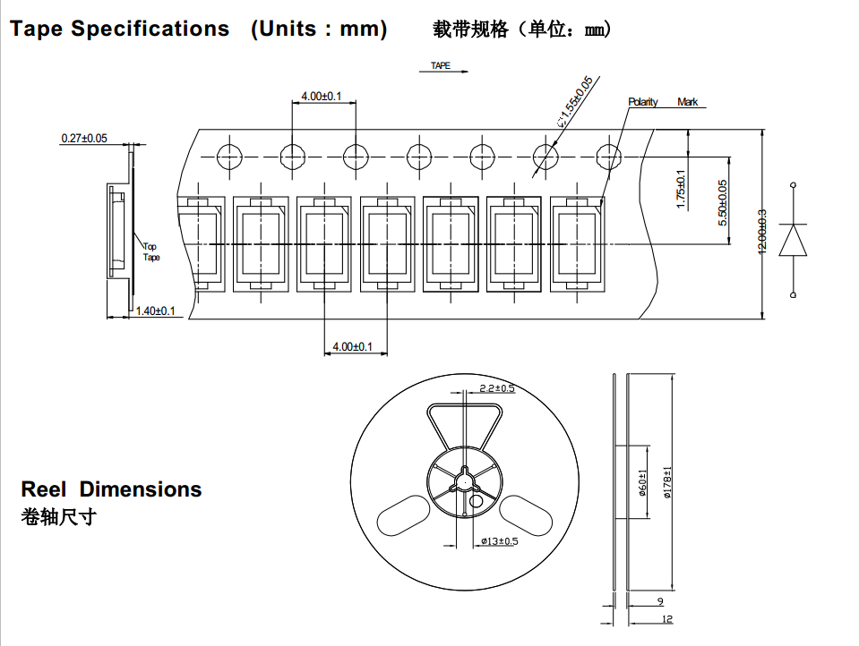
注意事项：

- 通过使用适当的工具从材料侧面夹取，不可直接用手或尖锐金属压胶体表面，它可能会损坏内部电路
Through the use of appropriate tools from the material side of the clip, can not be directly used by hand or sharp metal pressure on the surface, it may damage the internal circuit
- SMD吸咀外径不可超过LED尺寸，吸咀内役尺寸应尽可能大，吸咀顶端材质建议采用柔软材料以防在吸取期间刮伤或损坏LED胶体表面，元件的尺寸必须在取放机里准备的编程好，以确保精确的吸取和避免生产过中的损害
SMD suction nozzle diameter can not exceed the size of LED, the suction mouth battle size should be as large as possible, ceiling tip top material suggestions made of soft material to prevent absorb during scraping injury or damage the LED colloid surface, the size of the components must be in good pick and place machine to programming to ensure accurate absorption and avoid damage in production

- 不可将模组材料堆积在一起，它可能会损坏内部电路
Do not stack module materials together, it may damage the internal circuit

- LED工作环境与LED适配的材料中硫元素及化合物不可超过100PPM
LED working environment is very suitable for the materials of LED and sulfur elements and compounds can not be more than 100PPM

- 当我们需要使用外封胶涂抹LED产品时，应确保外封胶与LED封胶胶水相匹配，因为大多数LED的封装胶水为硅胶，它有较强的的氧化性和较强的吸湿性.
When we need to use seal glue smearing LED products should be really warranty seal glue and led sealing glue glue to match, because most of the LED package glue is silica gel, it has strong oxidation resistance and strong hygroscopicity

- 在开包装之前，请先检查包装袋有无漏气，如有漏气现象，请退回我司重新除湿包装再使用。
Before opening the package, please check the packing bag is free of leakage, if there is leakage phenomenon, please return the division to re - use the packaging and re - use

- 要在规定环境条件中使用：温度30℃以内，湿度60%RH以下
To be used in the provisions of the environmental conditions
- 折包使用前：请用70℃除湿24小时后才可以使用
Please use 70 degrees 24 hours before you can use the10 after the use of the material is more than 24H of the use of time is not used up

- 材料拆装后使用时间超过24H未用完，需烘烤70℃/24小时除湿才可使用。
Need to bake 70 degrees /24 hours before the use of the desiccant can be used.

