Approval Sheet

Customer：

Item： TOP VIEW LEDS

Part No.: WLUE2835D-1105-Y

Customer P/N:

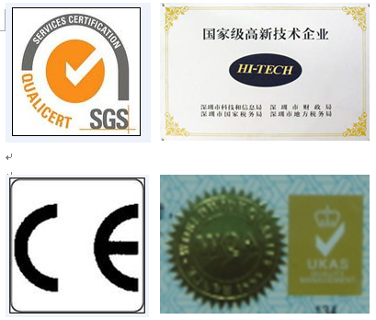
稳亮电子有限公司
WEN LIANG OPTO-ECTRONICS CO.LTD.
Add: Building 6,Xiaweishui Industrial District,
Hongqiaotou Songgang Street, Bao'an,
Shenzhen, Guangdong, China (513000)
Tel: 0086-755-29785289
Fax: 0086-755-29785189
E-mail: szwenliang@163.com
Website: http://www.szwenliang.com

PREPARED BY | CHECKED BY | APPROVED BY |  | SIGNATURE | CHECKED BY | APPROVED BY

供方签章： 客户签章：
SUOOLIER： CUSTOMER：

日期： 日期：
DATE： DATE：
备注：承认签章后请回复一份（或复印件）给我公司，其余由贵司留作存盘。如果在签章的承认书（或复印件）回复我司之前，下了有关此零件的订单且又无特殊说明，那么我司就确定贵司已完全承认。
Please return one specification or one copy of it with your chop and signature of approval and retain the others for your record.In the event of an order being placed for this part number before the chop and signed with specification (or copy) is returnde and without special explanation,it will be assumed that full approval have been given.

TYPE NO: WLUE2835D-1105-Y

PACKAGE DIMENSIONS

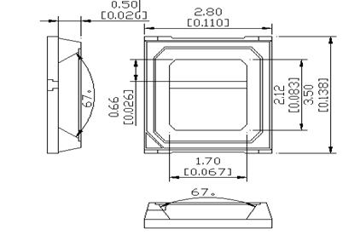

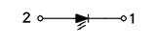

Device Selection Guide
Emitting Color | Lens Type
Red | Water Clear
Absolute Maximum Ratings at Ta=25℃
Parameter | Symbol | Max | Unit
Power Dissipation | P_{d} | 206 | mW
Peak Forward Current  1/10 Duty Cycle,0.1ms Pulse Width | I_{FP} | 200 | mA
Forward Current | I_{F} | 30 | mA
Reverse Voltage | V_{R} | 5 | V
Operating Temperature Range | Topr | -40℃ to+100℃
Storage Temperature Range | Tstg | -40℃ to+100℃
- ** LED allowable pressure value during SMT process.
- Electrical Optical Characteristics at Ta=25℃
Parameter | Symbol | Min | Typ | Max | Unit | Condition
Forward Voltage | VF | 2.0 | 2.2 | 2.4 | V | IF=150mA
Luminous Intensity | IV | 11 | 13 | -- | Lm | IF=150mA
Dominant Wavelength | λd | 620 | 625 | 630 | nm | IF=150mA
Color Rendering Index |  | -- | -- | -- | -- | --
IF=150mAReverse Current | IR | / | / | 5 | μA | VR=5V
Viewing Angle | 2θ1/2 | / | 120 | / | deg | IF=150mA

Note.
1. The Forward Voltage tolerance is ± 0.03V.
2. Correlated color Temperature is derived from the CIE 1931 Chromaticity diagram.
3. The luminous intensity tolerance is ± 10%

Typical Electro-Optical Characteristics Curves

Surface Mounting Condition
In the automatic mounting of the SMD LED to the PCB, any bending, expanding, and pulling forces against the SMD LED should be minimized to prevent the electrical failures or mechanical damaged.

Reflow Soldering and Temperature Profile
The SMD LED is designed for the reflow soldering process. Too high temperature or too large temperature gradient may cause the electrical and optical failures

Lead Solder
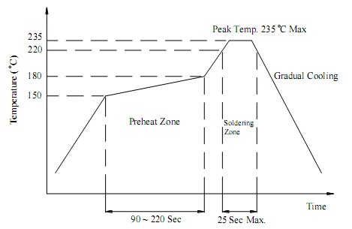

Lead–Free Solder
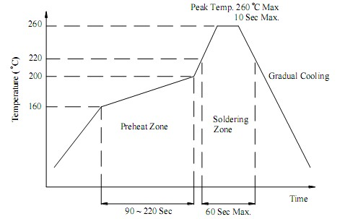
CarrierTape
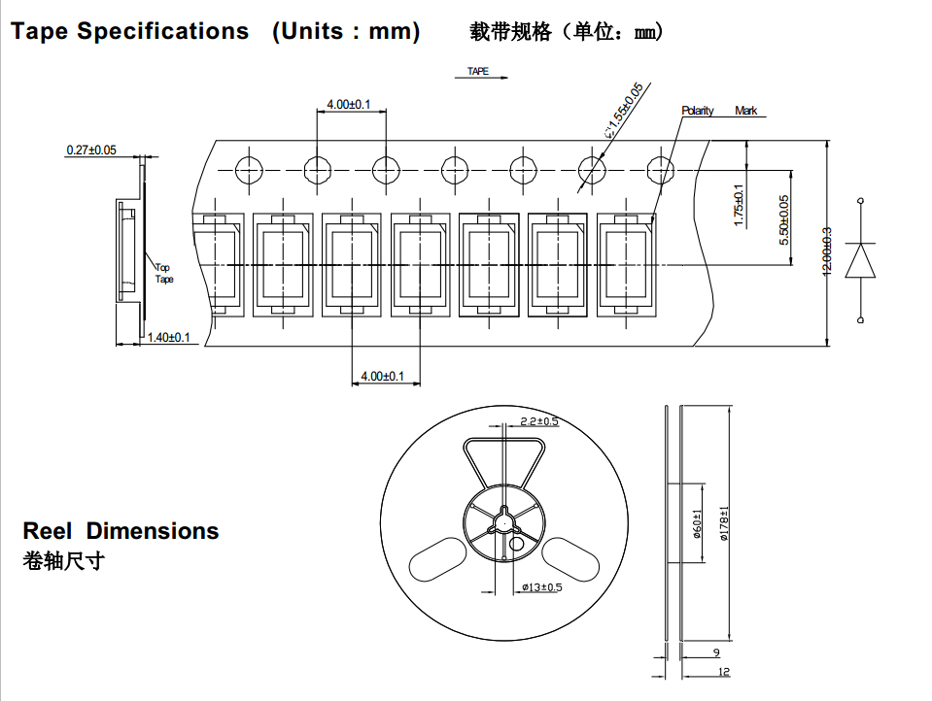
Caution
1.Before open the package, should kept at 30℃, 90% RHenvironmentor less, The LED should be used within a year.
2.After open the package, the LED should be kept at 30℃, 60 % RH environment or less. The LED should be soldered within 168 hours ( 7days ) after opening the package. If unused LEDs remain, they should be stored in moisture proof packages, such as sealed containers with packages of moisture absorbent material (silica gel).
3.The SMD LED is an ESD sensitive device. All the equipment and machine must be properly grounded.
4.Applying proper resistor for the circuit design is recommended. Otherwise slight voltage shift may cause big current change and the LED may be burn out.
5.LED module of 2 pcs (including more than 2 pcs), we suggest that different reels do not assemble together at the same module.
6.
LED Pre-Bake Notice:After the package opening over 168 hrs in 30℃, 60% RH or less. LED should be baked at70±5℃/ 24 hrs before using.
7.The design ofBack Light Module (BLM) is proposed: LEDs and BLM’s frameshould keep 0.4 mm of distances, or insulate between them, in order to avoid shorting out.

